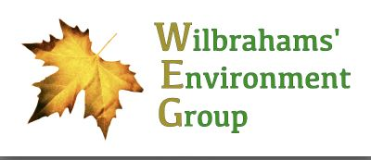

***Nature-Friendly Farming***

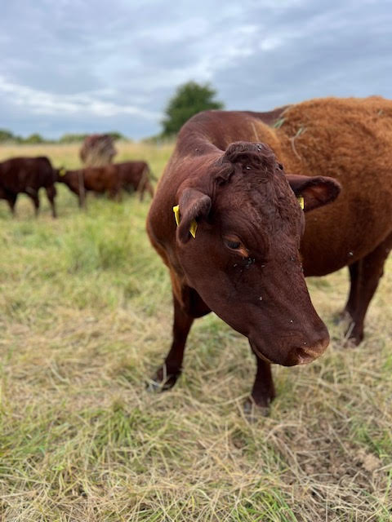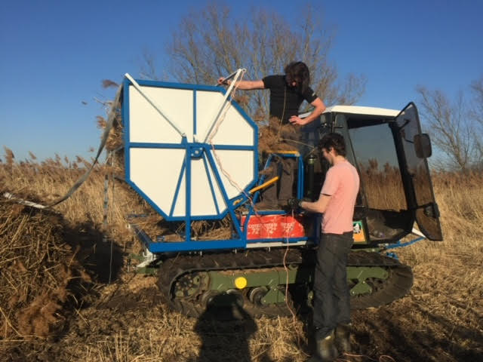**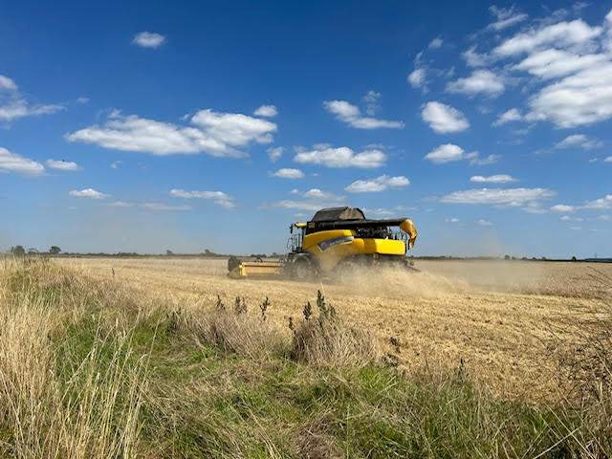*on the Quy Hall Estate***

The enthusiastic family owners of the estate will be explaining their progress to date and their ongoing plans for Frog End Farm in Little Wilbraham. If you want to talk all things conservation grazing, reed harvesting, biodiversity and regenerative agriculture, now’s your chance!

Come along to an Illustrated Presentation at

Wilbrahams’ Memorial Hall Great Wilbraham CB21 5JG

**Tuesday 8 October, 7.15pm**

**ALL WELCOME!**