St Nicholas Church, Great Wilbraham

Working together to be a Christian Community of Worship, Welcome and Care

Deanery of Fordham and Quy, Diocese of Ely

Parochial Church Council
Annual Report & Financial Statements
For the year ended 31st December 2016

Parochial Church Council 2016
The following served as members of the PCC:
Incumbent: The Revd Alice Goodman
Licensed Lay Minister: Steve Mashford
Churchwarden: Lorna Carr
Treasurer: Jeremy Barnett
PCC Secretary: Lorna Carr
Representative on the Deanery Synod: Steve Mashford
Elected members: Gillian Humphrey, Allan Painter, Helen Clarke, Phil Gorman,
Co-opted during the year: Judy Hanmer, John Beadsmoore

BACKGROUND
The Parish Church of St. Nicholas (grade II* listed), is typical of many village churches found throughout England, and forms an integral part of the village landscape. For some 900 years villagers have prayed and worshipped in a building on this site (parts of the present church date back to this period). It remains a focus for worship in our community as well as a versatile asset for community use.
The Parochial Church Council is responsible for promoting the whole mission of the Anglican Church within the Parish of Great Wilbraham, encompassing all pastoral, evangelistic, social and ecumenical aspects of the work of the Church. It is part of a Plurality with St Vigor’s, Fulbourn, St John the Evangelist, Little Wilbraham and St George’s, Six Mile Bottom. The PCC has maintenance responsibilities for the church building and churchyard area.
Members of the PCC are either ex officio or elected by the Annual Parochial Church Meeting (APCM) in accordance with the Church Representation Rules. The PCC meets at least 4 times a year but also operates through a number of informal groups or committees, which meet as required during the year, often as a result of issues raised at PCC meetings. These include the Standing Committee, (the only committee required by law with the power to transact the business of the PCC between its meetings, subject to any directions given by the PCC), a Fabric Committee and a Worship Group. Committee reports are included in the Appendices

UPDATE
What a difference a year can make!
The long awaited toilet and kitchen have been completed with the simple design much admired. The new facilities prove to be useful all the time, it is so nice to be able to say, “yes, of course” when asked if we have a toilet by people attending weddings, funerals and the regular services!
A very successful Songs of Praise service was held on 11th September with Arch Deacon, Alexander Hughes officially opening the completed Tower Project.
Revd Alice Goodman continues as our vicar and her dedication to her work this year has been greatly appreciated during the illness and death of her husband, Geoffrey Hill. Steve Mashford continues as our L.L.M.
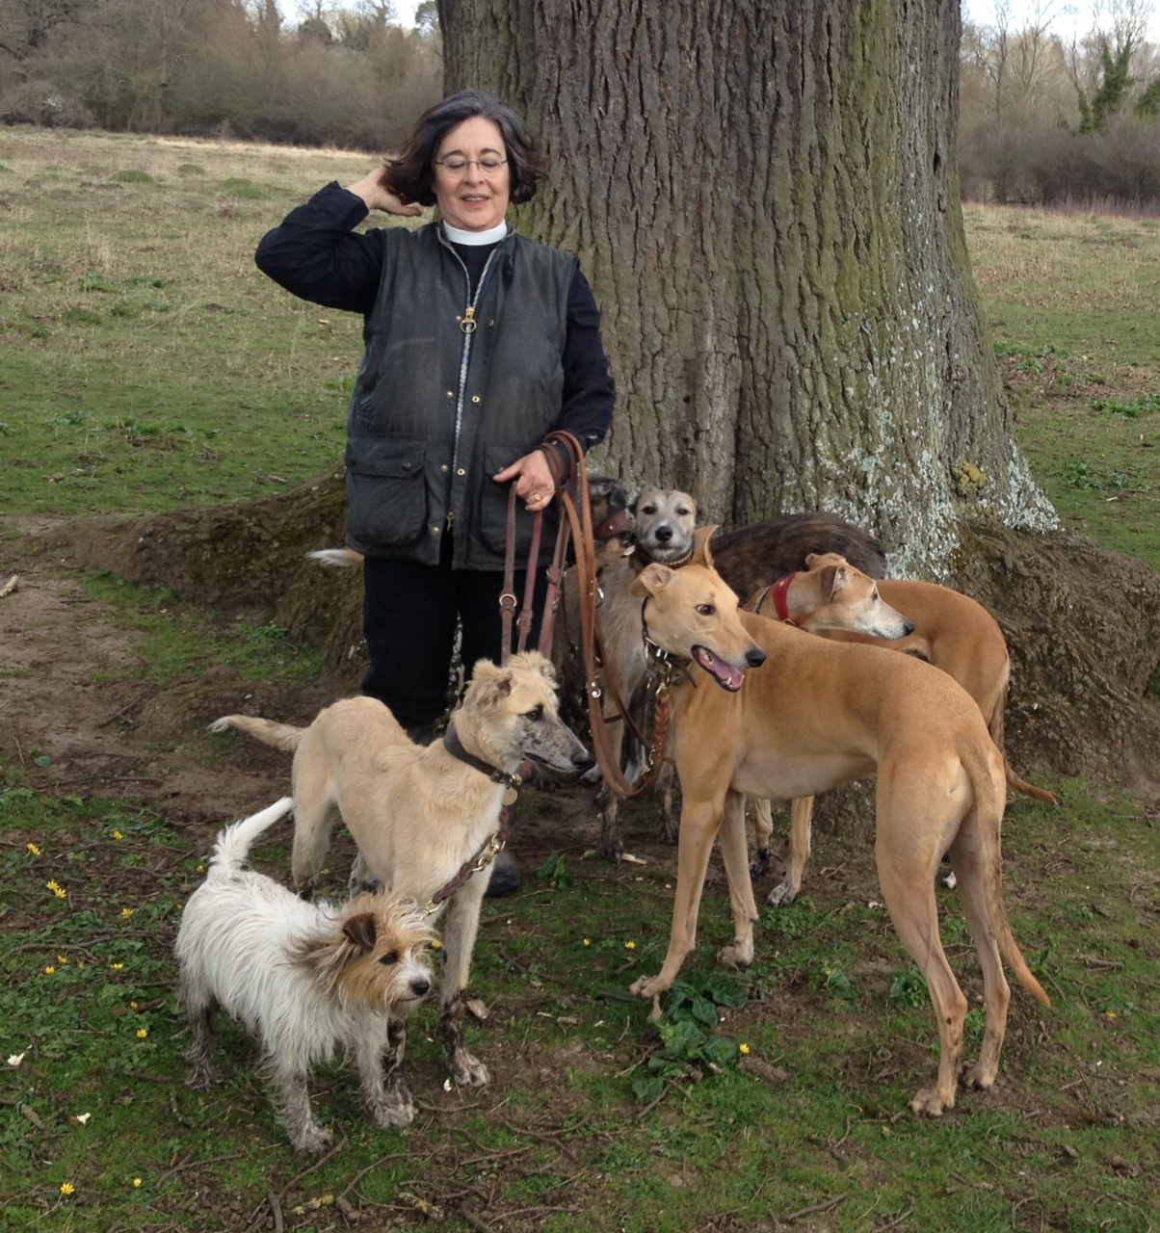
We have also benefited from the presence of our Ordinands, Elizabeth Brown, Angus Reid, Gareth Banton, Jassica Castillo-Burley and Jo Joyce. Our parish assistant, Susie Rogers continues to support the work of the church in this benefice in many ways and is based at Twelve, the parish office and second hand book shop in Fulbourn High Street
The service pattern of a 9.30am Holy Communion on the third Sunday of the month continues, with Come and Join on the first Sunday.
Morning Worship, following the Iona Service book, is still held in the church every Wednesday at 9.15am.
Home communion is available with additional people being trained to carry this out, this new group of DBS checked volunteers also visits villagers who have recently returned from hospital or just appreciate a chat.
There was the usual Walk of Witness between Great and Little Wilbraham on Good Friday. Joint services for the Wilbrahams and Six Mile Bottom are still held on the 5th Sunday of the month at St George’s, Six Mile Bottom.
Harvest Festival was celebrated on Sunday 2nd October with Come and Join and also Sunday 16th October with a traditional communion service. Collections at these services were taken for Christian Aid and donated non perishable food was taken to Jimmy’s Night Shelter. Christmas was celebrated with Six Lessons and Carols on Christmas Eve, where a full church enjoyed hearing the community choir and on Christmas Day with a service of Holy Communion. Refreshments were served after the Lessons and Carols service in aid of the Save then Children’s Syrian appeal, £203 was collected.

Close links with Great Wilbraham School have been maintained with regular visits from Alice and Susie. Holly Tilbrook continues as one of the foundation governors and Tim Brown’s appointment as the Archdeacon’s appointed governor was confirmed.
The church yard is still being maintained by a group of volunteers, Allan Painter had to step back from organising this group due to illness and Tony Ryan has taken over. Stan and Vivien Wilson maintained the area south of the church with care and dedication and we are very grateful to Chris Hanson who has begun the challenging job of removing ivy from the church yard walls. Judy Hanmer continues to care for the flower bed to the left of the porch, which looks lovely all the year round. Areas of longer grass were left to encourage more wildlife. These areas will be reduced in future due to difficulties in cutting the long grass in late summer. An extensive programme of tree pollarding took place over the winter. There are now only five burial plots remaining in addition to the cremation spaces.
We still have the church open on a daily basis from 9am to about 6pm thanks to a small team of volunteers. We know this is appreciated by comments in the visitor’s book.
Cleaning the church and ensuring there are flowers present, continues to be organised on a rota basis by volunteers for which we are very grateful.

LOOKING FORWARD TO 2017/18
We are optimistic that the new facilities will enable us to continue to develop our links with the village and the school. There is the opportunity to hold group meetings, lunches, concerts and other activities in the beautiful new space with up to date amenities.

APPENDICES

Safeguarding children and vulnerable adults
As a benefice we have adopted a new policy showing we are committed to valuing, listening to and respecting children, young people and vulnerable adults. This includes safe recruitment, supervision, training and DBS checks where applicable.
This policy is available in Twelve and each church.
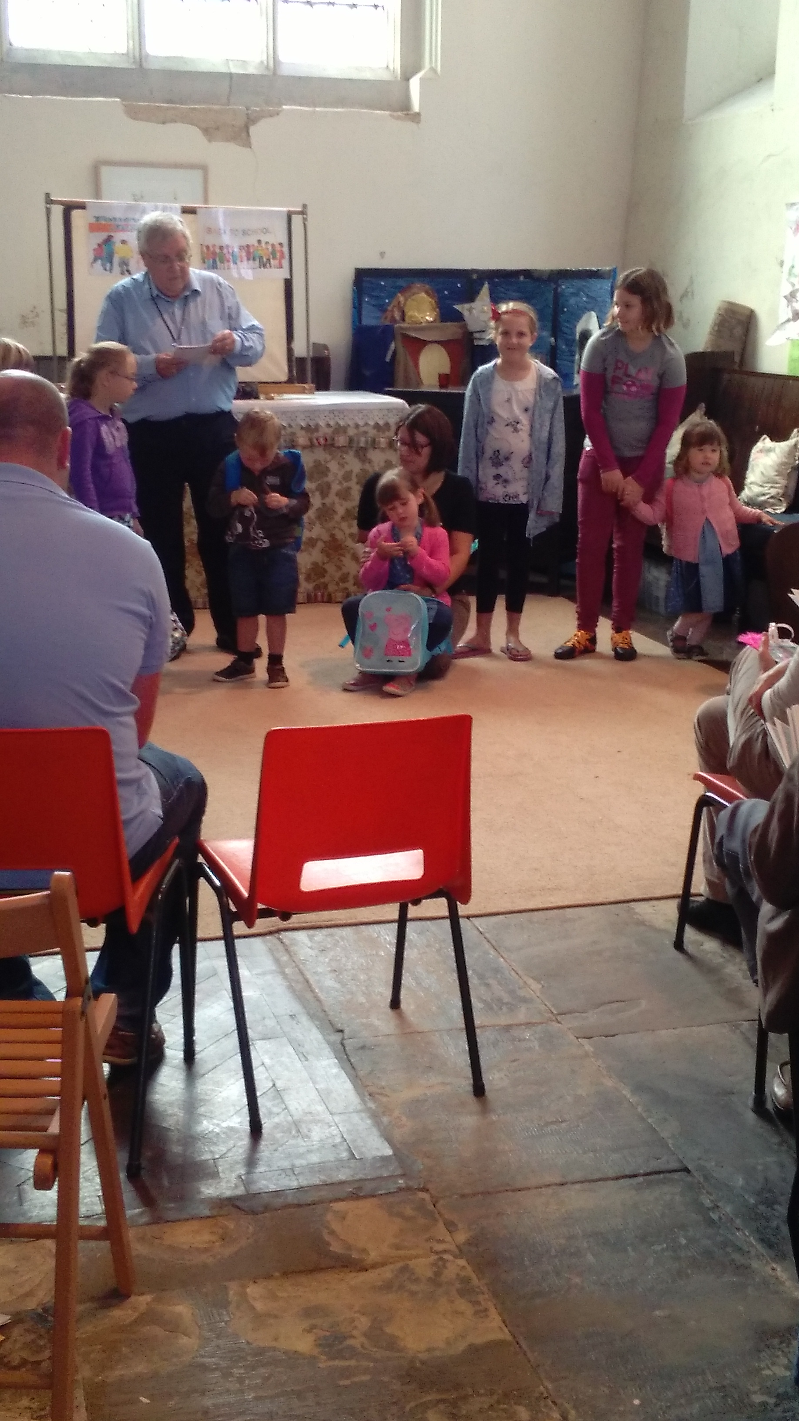 Come and join…

In September we celebrated the 3rd birthday of our ‘Come and join…….’ Worship services they take place on the 1st Sunday of the month at St Nicholas Great Wilbraham at 9.30. This year we added another dimension now we have a kitchen and toilet, in September and October, serving ‘Breakfast’ during the service.
The Come & Join services include sketches, dramatized Bible readings and a talk that includes visual displays. The music is a blend of worship songs and traditional hymns. We have celebrated ‘ Come and join…. The Bread of Life, Vine and Branches, The Family, The Saints, Advent Celebration, Epiphany, Candlemas and Lent.’
The service is led by Steve Mashford, our Licensed Lay Minister, and all are welcome to ‘Come and join’ our worship on the first Sunday of the month.

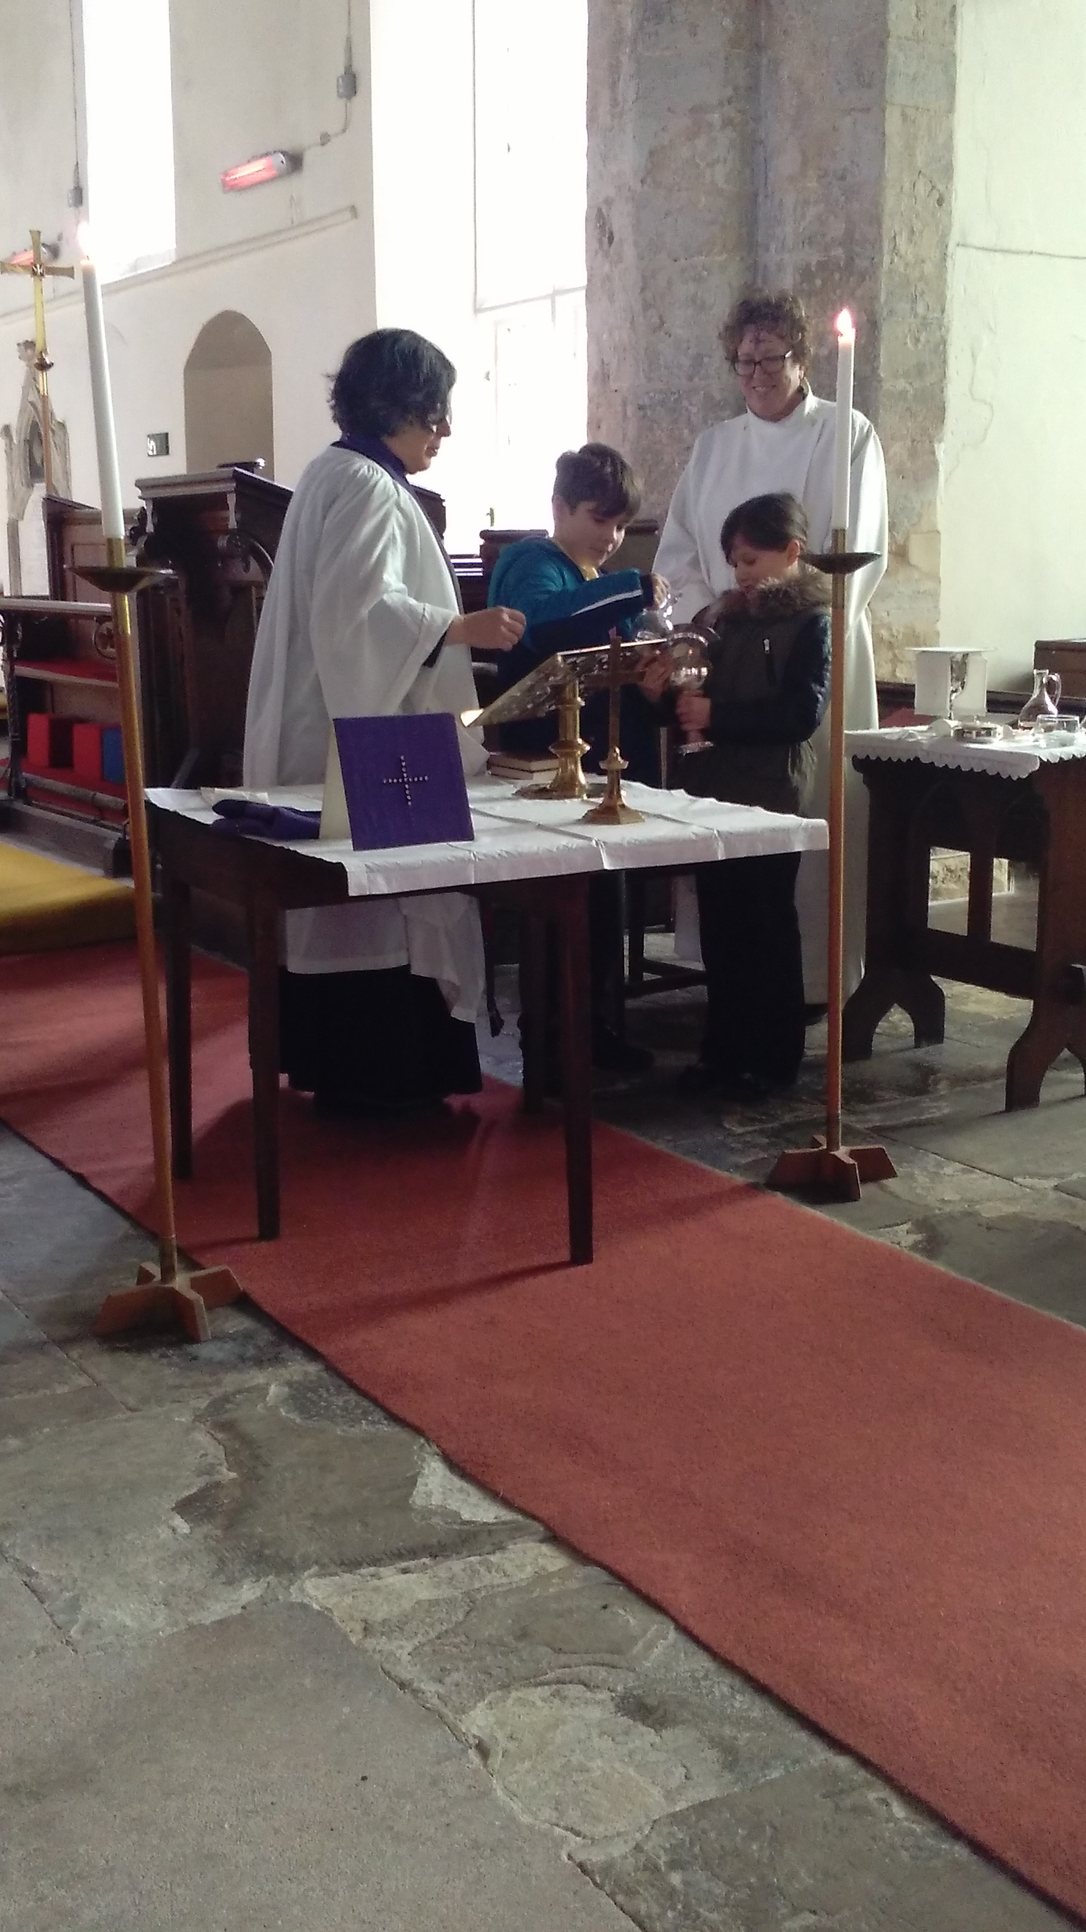
Schools Ministry-Great Wilbraham Primary School
Alice and Susie visit the school regularly, leading assemblies and chatting in the classrooms to the children and staff. The children all know them very well.
Susie goes at least once a week. She runs Happy/Sad club weekly. This used to be run as one group but she felt it would be more beneficial for the students to be split into KS1 and KS2. Now each group meets fortnightly and this works better because they are able to talk about more age appropriate subjects. Susie has been involved in running collective worship since September and during the lead up to Christmas she went to the Wednesday music assemblies with Tim Brown and taught the children the first two verses of Silent Night in German which was then sung during the Christmas service.
A group made Mothering Sunday posies with Badger class again this year and every child was able to take one home.
The school held a Leavers service, Christmas and Christingle services in the church this year. Key Stage 2 children also attended St. Nicholas’ Imposition of Ashes service, with many children coming forward for an ash cross on their foreheads’ and a blessing.

Evening & weekday meetings
During the year we have been gathering together to study The Pilgrim course, an ecumenical course looking at all aspects of Christian and Church life. It is for those just starting on the journey and also those of later years to recall why we do such things in our services held at St Nicholas. Last year in Lent we used some material produced in Norwich Diocese to prepare us from Ash Wednesday to Easter Sunday. The year we are using a course designed by our own Diocese on the theme ‘All loves excelling’ and is linked into the strategy ‘People Fully Alive Ely2025’

Bible Study group
The Bible study group has continued to meet in the village, generally at Stephen and Marilyn Harmer’s house fortnightly on a Monday afternoon.

Coffee and Chat
“Coffee and Chat” is still on the first Monday morning of each month at the home of Ann Neale. This is a greatly valued opportunity for people in our community to meet in a relaxed and friendly atmosphere.

Twelve
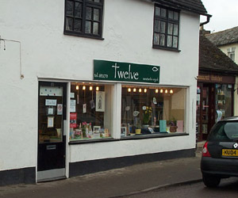Based in Fulbourn, Twelve continues to be an excellent centre for administration, communication and outreach across the benefice and provides office space for our parish assistant. In addition it is a centre for community communication, displaying posters and flyers for future events. Twelve hosts numerous community events in addition to providing space for joint church meetings and groups. Twelve is manned by volunteers and sells greetings cards, second-hand books and jigsaws. Opening times: Monday 1.30-4.30pm, Tuesday, Thursday and Friday 9.30am – 4.30pm, Saturday 9.30am – 12.30pm.

Facts and figures
There are 42 people on the Electoral Roll.
The average attendance at the Sunday morning services held at St Nicholas was 21 adults and 2 children and young people. At the mid-week service at 9.15am on Wednesday mornings on average 5 people attend.
The Easter Day communion service was held at St John, Little Wilbraham. 182 adults and children attended the Christmas Eve and Morning services.
During the year there were one baptism, two weddings, and five funerals. Three services were held for Gt Wilbraham Primary School. Our All Souls service was on 2 November and our Blue Christmas service was on 21 December.
The main points on the church finances in 2016, which are detailed in the Annual Accounts, are:
• We started the year with general funds of £798 and ended with £272.
• We paid the Ministry Share of £10,575, insurance of £2,573, the joint expenses due to St Vigor’s, Fulbourn of £860 and other costs totalling £3,586.
• During the year we supported: Great Wilbraham Primary School £300, Jimmy’s Night Shelter £372, Medecin Sans Frontiere £300 and the National Churches Trust £50. In addition bibles were presented to leavers at Wilbraham Primary School. Special collections were taken for East Anglia Air Ambulance, £65, Royal British Legion, £35 and Save the Children, £203.
In addition to monetary support, donations of food and household items were given to Jimmy’s Night Shelter and the Besom Christmas Hamper project during 2016.
• The major financial undertaking in 2016 was the Tower Project as summarised below. A grant of £1,241 from the St Nicholas Great Wilbraham Trust enabled the organ to be dismantled, cleaned and refurbished.
The net income from the 5 Benstead End investment property was £6,778.

Investment property-5 Benstead End, Great Wilbraham
Two tenants have rented the investment property during the year producing rent of £16,061, excluding the rent deposits. The total costs in the year were £9,283 including decorating and new flooring. We are grateful to Graham Clarke for his continued management of the property, free of charge, throughout the year including the re-letting.

Deanery Synod report
We welcomed Rev Michael Banyard as our new Rural Dean. Later in the year we were told that Michael will be retiring on the 1st May 2017.
Our meetings this year have carried on the theme of People Fully Alive 2025. Following the successful road shows last year we have had ministry and mission focused meetings with Linda Church and Peter Wood the Director of Ministry and Mission leading them as a double act. Not only did we hear what is happening in the Diocese, but also we had time to share what also was happening in the Fordham and Quy Deanery.
We look forward to where God will lead us in the coming year and what our vision is from now to 2025.

Fabric Committee report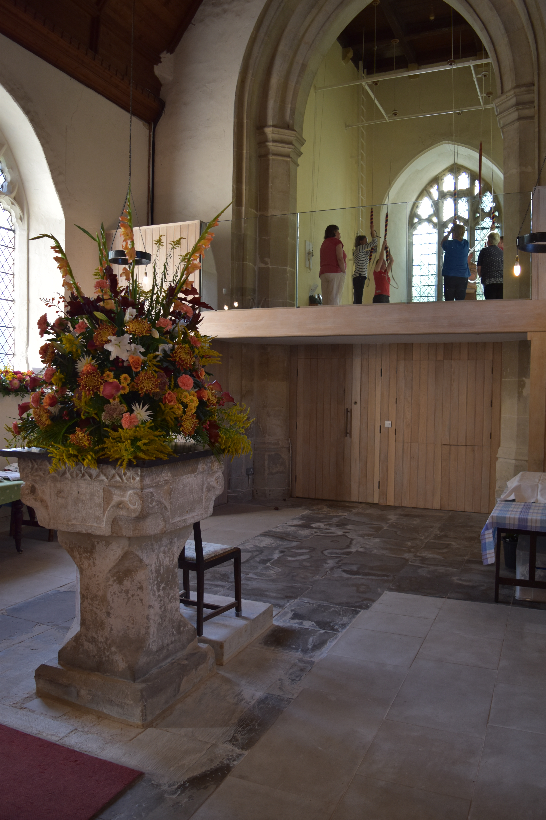
The major work in 2016 was the Tower Project. The construction work for the Tower Project started in February 2016 and was completed in July 2016. This had been preceded in 2014 and 2015 by the hard work of the wardens, combined with the pro-active advice from Archangel, our architects. This had resulted in an agreed design and planning approval being achieved for the installation of a new kitchen and toilet in the church tower area, with a new ringing gallery above. In addition, this would create an enlarged, open area at the west end of the church.
The income and costs of the Tower Project are summarised in the Annual Accounts. Net of VAT recovered to date, the costs, including accruals for the final invoices, totalled £135,446.
The costs were financed by a combination of grants, donations, fundraising events and a loan, repayable out of future net rents from the investment property. The grants and other funding included;

Grants | £
The St Nicholas, Gt Wilbraham Trust | 45,000
Amey Community Fund | 27,600
The Joseph Rank Trust | 15,000
The Garfield Weston Foundation | 3,000
The Allchurches Trust | 1,750
 | 92,350
Donations, fundraising by the congregation and net funds from the investment property | 20,519
Settlement with the Ely Diocesan Board of Finance | 12,500
Loan | 25,000
 | £150,369

A Songs of Praise service and reception was held on 11 September to celebrate the completion of the project. We were pleased that the Squires Family were fully represented following the generous donation of Mrs Gwen Squires towards the funding.
The balance of the funds are retained for the maintenance of the investment property and the church. The loan will be repaid as funds permit out of future rents from the investment property.

The plans for 2017 are outlined in the St Nicholas Trust report.

Great Wilbraham Guild of Change Ringers : Annual Report 2016 - 2017.
On February 18th 2016, we rang for the last time in the ground floor ringing room at St. Nicholas’; before the renovations to the west end of the Church began. This continued through to mid July; when we were given final access to the new ringing gallery. All agreed it is splendid.
The first post-renovations Quarter Peal was rung on Saturday August 7th.
Visiting ringers enjoy the new ringing space and book Peals and Quarter Peals with us.
During the renovations, between February and July, we rang at Bottisham with our friends, and also at Sawston on some Thursdays. Members of the GWGCR band helped to train new ringers in Sawston, and we continue to support them.

During the year we joined with the Cherry Hinton band and entered a team for the local Gipson Trophy striking competition which involves many bands. We came joint second!
Great Wilbraham also entered for the District Striking competition on July 9th, which we hosted, at Brinkley. We came a respectable third against more experienced bands, and we were also awarded the Annual President’s Award. Not bad for a small band.

We have settled into our regular ringing routine and ring for Sunday Services and other special services.
On Remembrance Sunday we rang the bells “half muffled” just before the Service for the Dedication of the Memorial Hall.
Christmas services were rung as usual.

St. Nicholas Trust report
The St. Nicholas Great Wilbraham Trust is currently made up of a maximum of five members of the village, the incumbent (based in Fulbourn) an extra co-opted member of the village and two members of the PCC (Warden and Treasurer) as invited guests so as to maintain a close relationship between the Trust and the PCC. The purpose of the trust is to “raise money for the preservation, repair, maintenance, improvement, upkeep, beautification and restoration of the church and of any fitting, fixture, stained glass, organ or bell in the church but excluding the church yard adjoining the church……and the monies shall be given to the PCC to spend on works specified by the trustees …”.

At the 2016/17 financial year end, the accounts are projected to show a balance of £16,812.45 (unaudited). The Gwendolyne Squire’s generous donation of £50,000 was fully spent last summer on the Tower Project, creating the new kitchen & wc (after over 1,000 years waiting!) and the release of more space to the back of the church, are all now available for everyone’s benefit. Also, £1,250 was donated for organ repairs. Looking ahead, a further £8,000 has been earmarked for the re-rendering to the north transept external wall, as per the architect’s recommendation in the November 2015 Quinquennial Inspection Report. Fund raising continues to be through villagers’ most kindly gift aided monthly donations, and later in 2017 we plan to set up a Legacy Donation Fund for the permanent long term benefit of the church.
Graham Clarke (chairman)

